Practical 3:

Problem Definition: Create a student registration form with HTML5 input types and JavaScript validation for name, email, mobile number, password, confirm password,course, year, gender, and terms acceptance. Use Regular Expression for validations.
Code:
1).register.html:
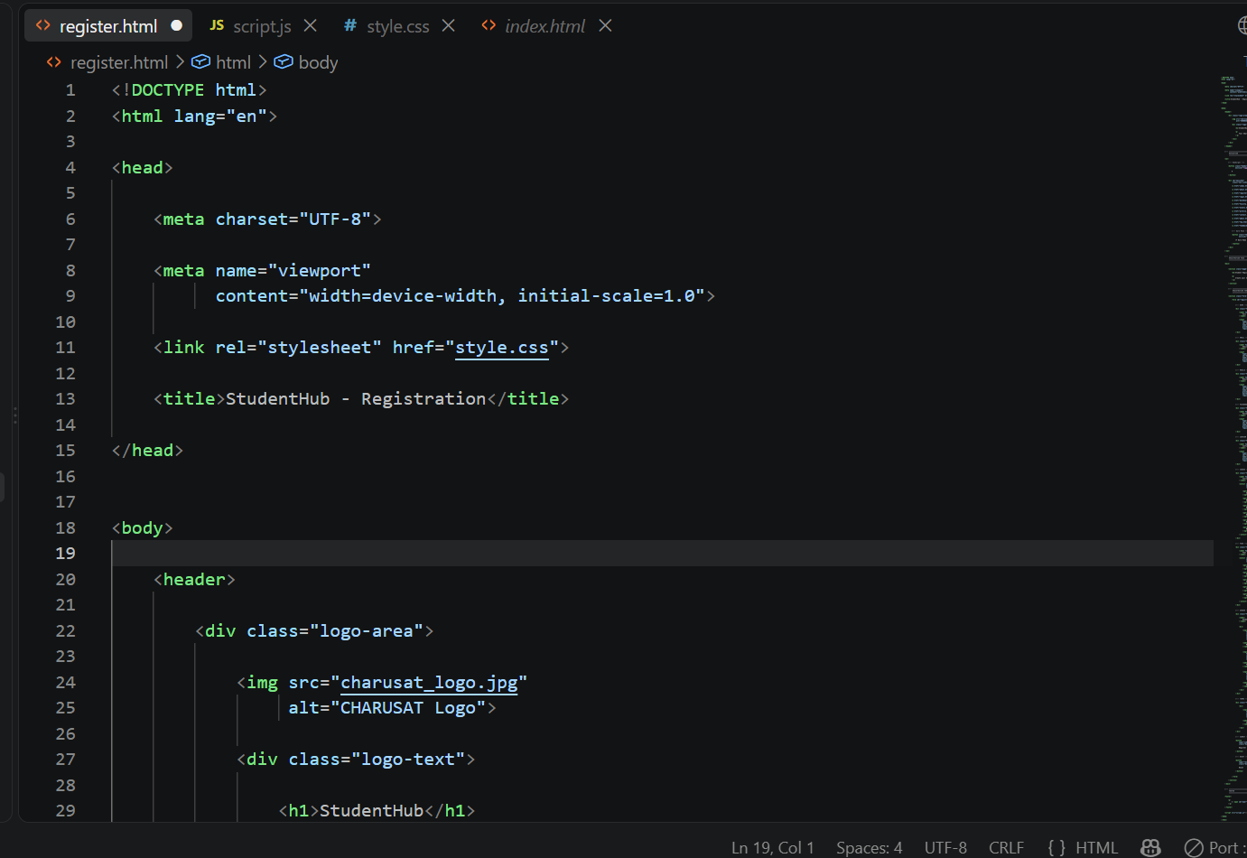
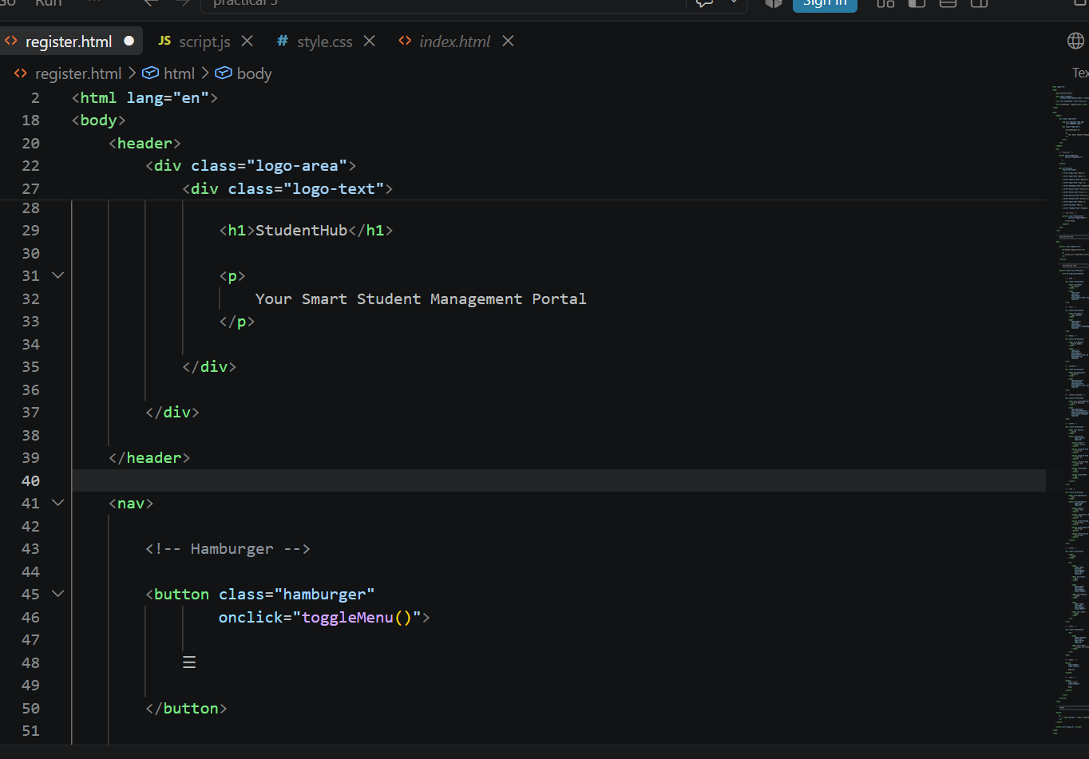

3)index.html:
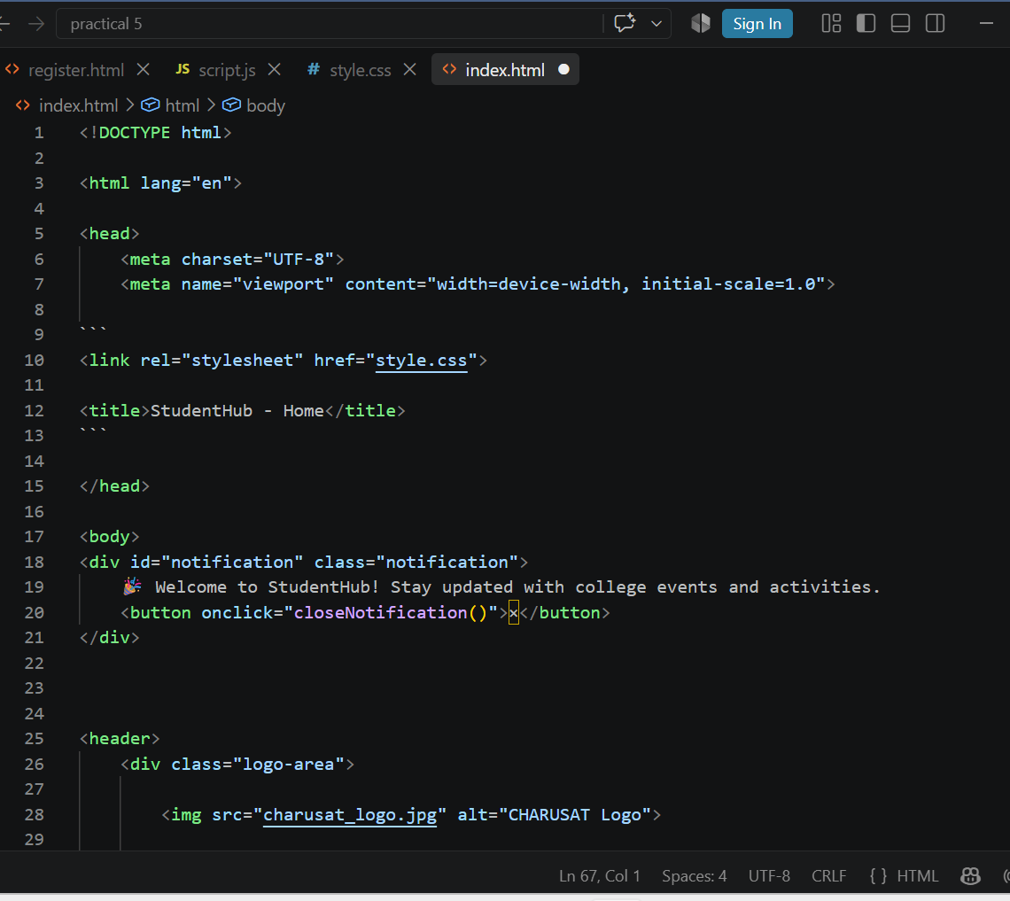
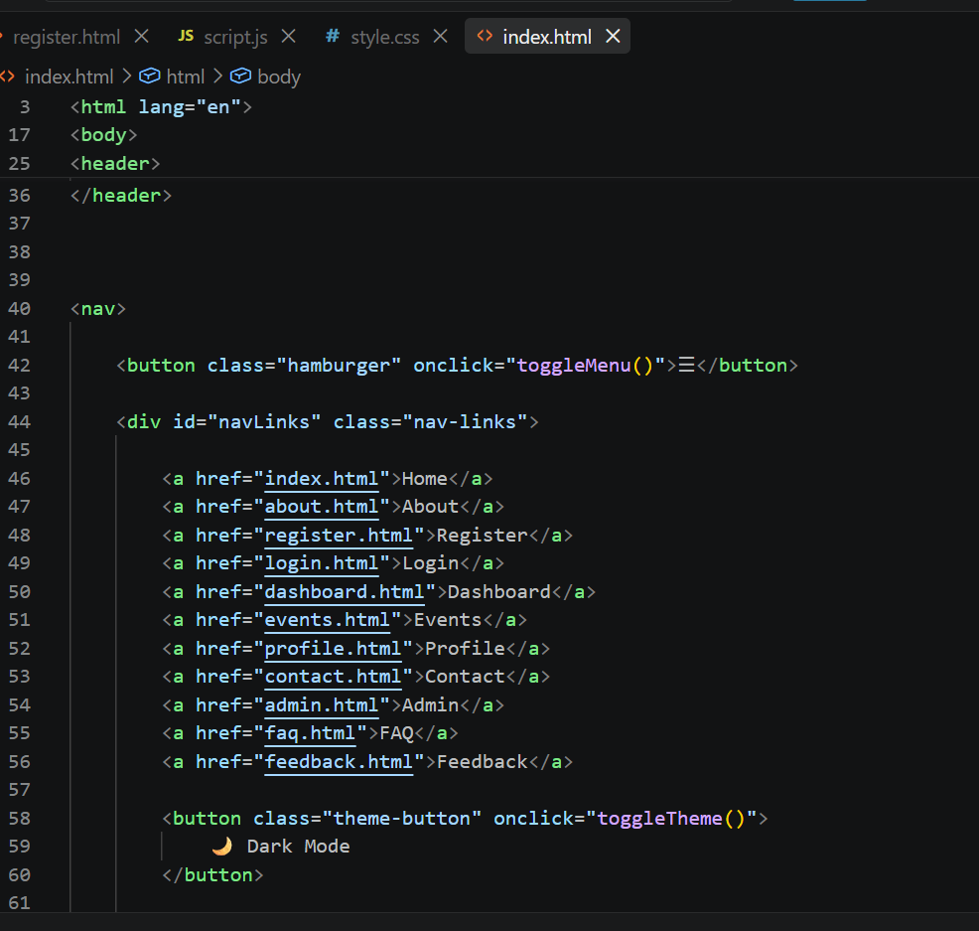

2)style.css:
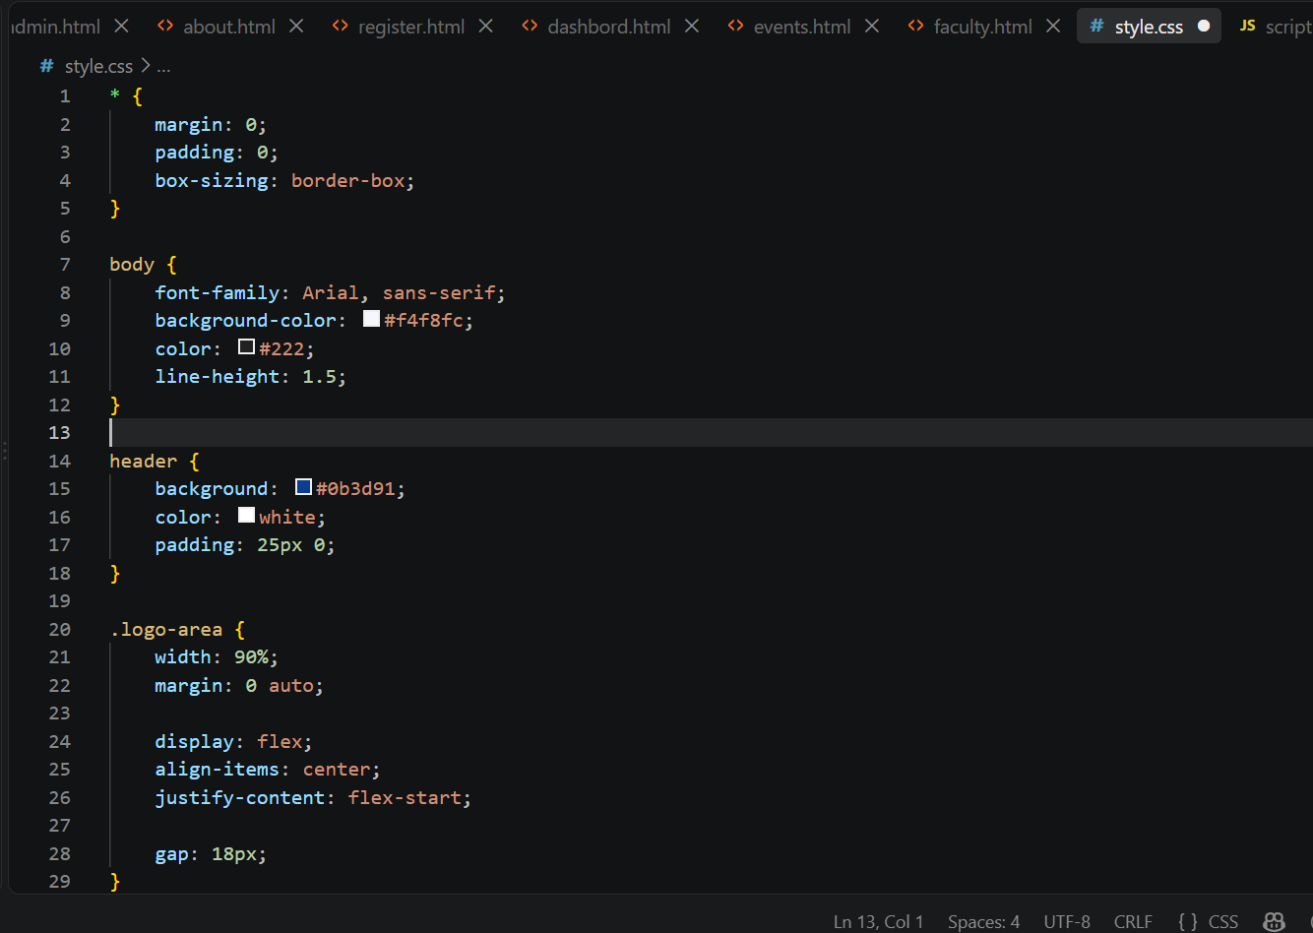
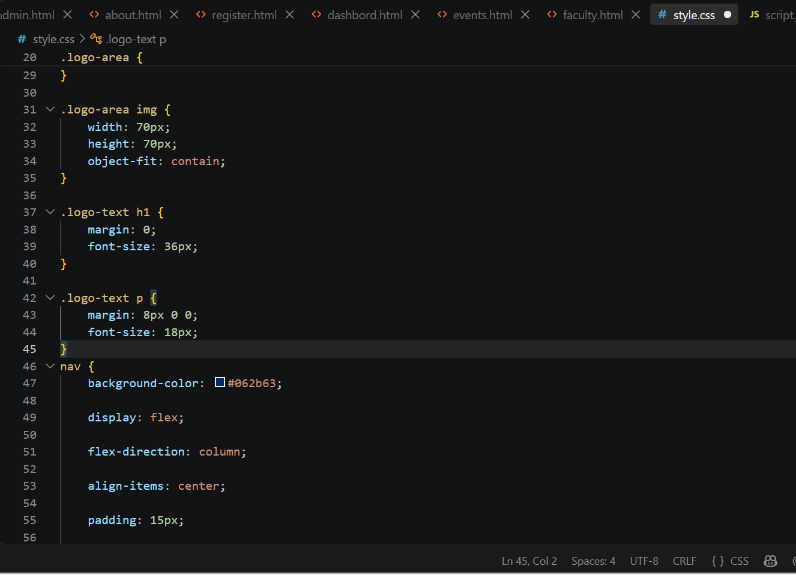

3).script.js:
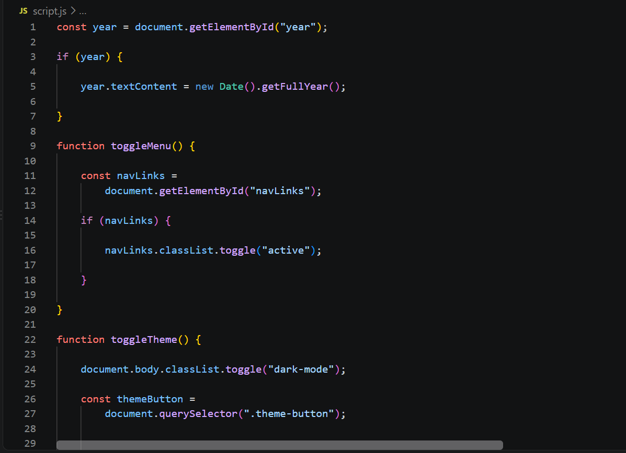
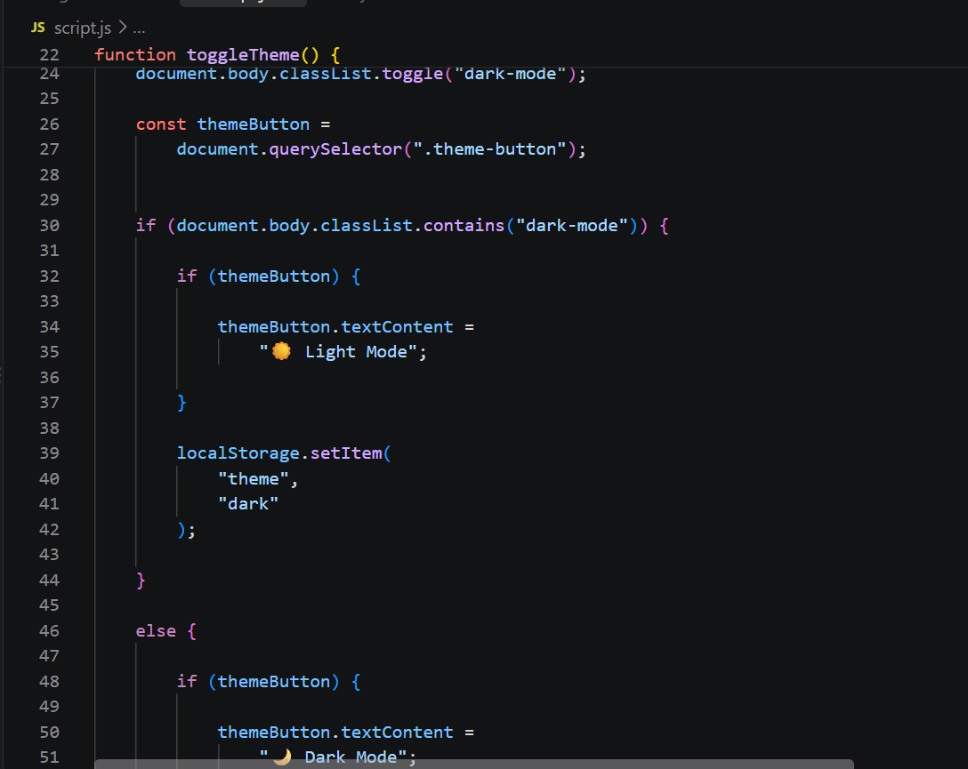

OUTPUT:
1)register page:
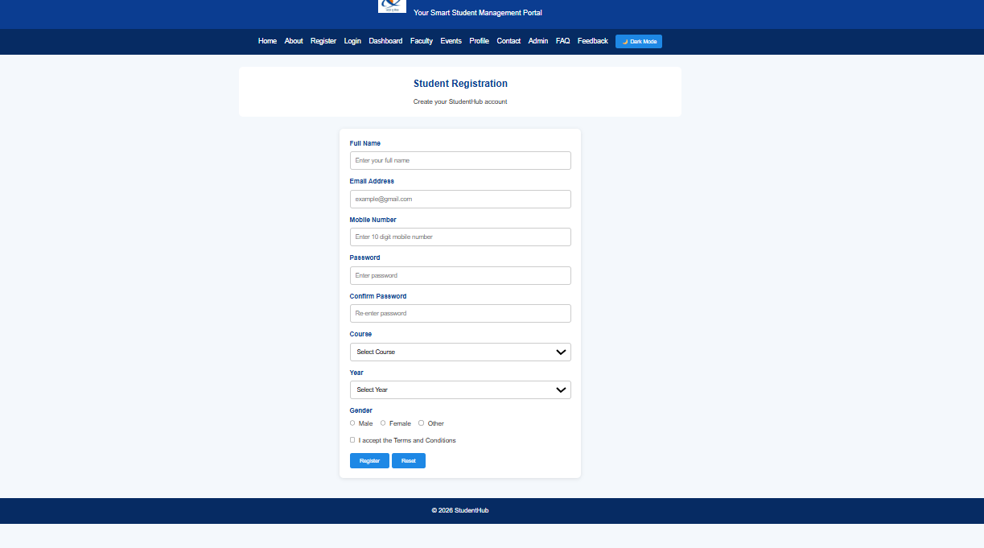
Question & Answer:
1. Are correct input types and attributes used?
ANS:Yes. Appropriate HTML5 input types and attributes are used, such as email, tel, password, required, minlength, and maxlength, to ensure proper data entry and basic browser validation.

2.Are validation errors displayed near the relevant fields?
ANS:Yes. Validation error messages are displayed close to the corresponding input fields, making it easy for the user to identify and correct the entered information
.
3.Is password strength checked?
ANS:Yes. The password is checked for strength by verifying requirements such as minimum length and the use of different types of characters, helping users create a stronger password.
4.Is the form accessible using keyboard and screen-reader-friendly labels?
ANS:Yes. The form uses proper labels associated with their input fields, and the fields can be accessed using the keyboard. This makes the form easier to use for keyboard users and screen readers.

Conclusion / Learning Outcome:
->The student registration form successfully demonstrates the use of HTML5 form elements, client-side JavaScript validation, password strength checking, and accessibility practices. This helps ensure that the form is user-friendly, accessible, and capable of preventing invalid data entry.

